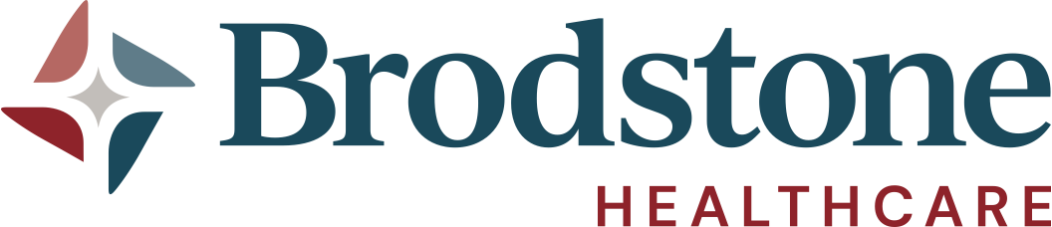

August 10, 2026
COMMUNITY NEEDS ASSESSMENT/COMMUNITY HEALTH IMPROVEMENT PLAN REPORT
Health Priority Goal #1: Elder/Senior Care

Goal: Increase access and support for older adults through transportation, age-friendly initiatives, education, and community resources.
2025 Progress:
- Continued use of the 4Ms Framework on the inpatient side.
- Conducted senior-focused education and outreach through the Health & Wellness Expo.
  - Included community partners such as the pharmacy and Caring Friends.
  - Provided information on services and resources available to older adults.
- Initiated community education opportunities through expo participation, which supported awareness around available senior services.

Health Priority Goal #2: Chronic Illness

Goal: Improve chronic disease management, prevention, education, and screening opportunities.
2025 Progress:
- Expanded Chronic Care Management through partnership with ChartSpan.
  - Increased enrollment from approximately 40 patients to 115 patients, exceeding the goal of a 10% increase in participation.
- Implemented a Heart Disease Awareness Campaign during February.
  - Utilized digital communication platforms and educational messaging focused on prevention and awareness.
- Increased screening and education opportunities through the Health & Wellness Expo.
  - Included cancer screening information and education from clinical staff.
  - Provided community education around prevalent chronic health conditions in Nuckolls County.

Health Priority #3: Mental Health & Wellbeing

Goal: Expand access to services, reduce stigma, strengthen community partnerships, and explore additional support resources.
2025 Progress:
- Progress made toward opening a Play Therapy service line.
  - Casey completed the required education/training in 2025.
  - Full implementation is anticipated in 2026.
- Limited progress on increasing referrals through school partnerships.
  - Communication occurred with local schools regarding needs and available support.
  - Schools already had mental health programming and speakers planned.
  - Brodstone offered assistance as needed.
- Conducted a Mental Health Awareness Month media campaign to increase awareness and reduce stigma.
- Participated in the Health & Wellness Expo, providing mental health education and resources.

Overall Summary
The most significant accomplishments in 2025 were:
- Expansion of chronic care management through the ChartSpan partnership.
- Community education and resource awareness through the inaugural Health & Wellness Expo.
- Continued inpatient use of the 4Ms framework.
- Advancement toward a new Play Therapy service line through staff training.
- Digital awareness campaigns focused on heart disease prevention and mental health awareness.
- Planning and development efforts to increase housing availability within the community through Brodstone Healthcare's Project SCOPE (Supporting Community Opportunities & Planned Expansion). This initiative was established to address local housing needs, support workforce recruitment, attract new families to the area, and promote long-term community growth through the development of new owner-occupied housing. This initiative is a goal in the current hospital strategic plan.

